**DAILY ONLINE ACTIVITIES SUMMARY**

|  |  |  |  |  |  |  |  |  |
| --- | --- | --- | --- | --- | --- | --- | --- | --- |
| **Date:** | **30/05/2020** | | | | | **Name:** | **NAIPUNYA VINOD NAIK** | |
| **Seem & Sec** | **IV SEM & A SECTION** | | | | | **USN:** | **4AL18CS050** | |
| **Online Test Summary** | | | | | | | | |
| **Subject** | | **1)DATA COMMUNICATION**  **2) COMPLEX ANALYSIS ,PROBABILITY AND STATISTICAL METHODS.** | | | | | | |
| **Max. Marks** | | **1)30**  **2)30** | | **Score** | | | **1)26**  **2)23** | |
| **Certification Course Summary** | | | | | | | | |
| **Course** | **INTRODUCTION TO CLOUD COMPUTING** | | | | | | | |
| **Certificate Provider** | | | **Cognitive.ai with IBM** | | **Duration** | | | **6 HRS** |
| **Coding Challenges** | | | | | | | | |
| **Problem Statement:** [Write a C Program to count Uppercase, Lowercase, special character and numeric values for a given String](https://github.com/orgs/alvas-education-foundation/teams/2nd-year/discussions/88). | | | | | | | | |
| **Status: EXECUTED** | | | | | | | | |
| **Uploaded the report in Gather** | | | | | **YES** | | | |
| **If yes Repository name** | | | | | <https://github.com/naipunya-naik/lockdown-coding/tree/master/C%20CODING> | | | |
| **Uploaded the report in slack** | | | | | **YES** | | | |

Online Test Details: (Attach the snapshot and briefly write the report for the same).

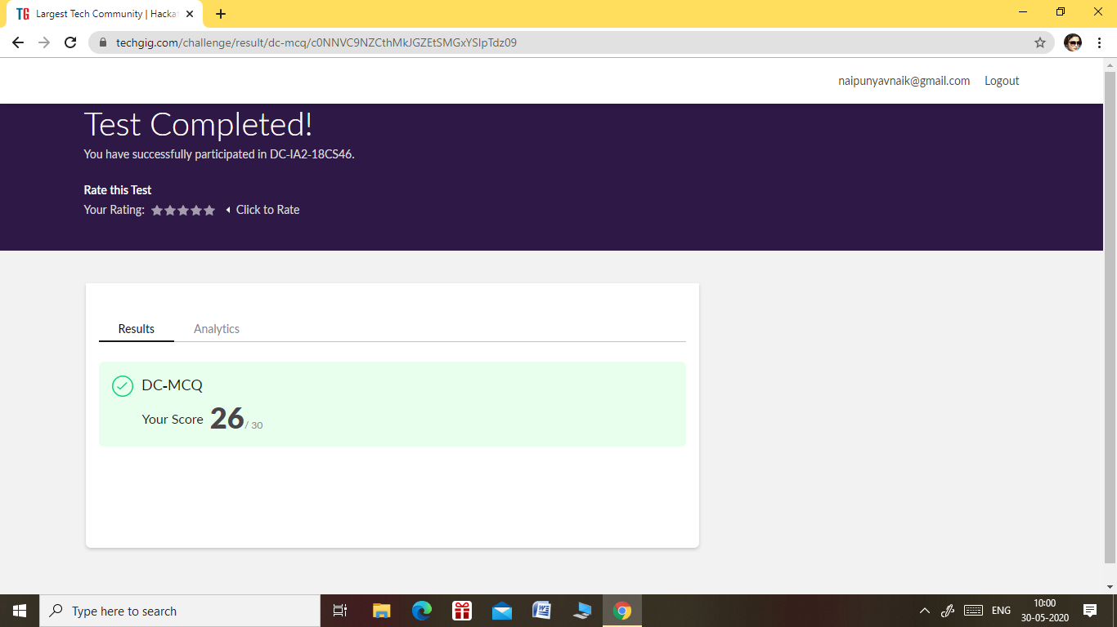

THE 2ND I.A TEST OF DATA COMMUNICATION WAS HELD ON 30 MAY 2020.

* SUBJECT :- DATA COMMUNICATION
* SYLLABUS:- MODULE 3 & MODULE 4
* NO. OF QUESTIONS:- 30
* START TIME:- 9.15 AM
* END TIME:- 10.00 AM
* DURATION 45 MIN
* EACH QUESTION CARRIED 1 MARK

2) THE 2ND I.A TEST OF COMPLEX ANALYSIS, PROBABILITY AND STATISTICAL METHODS WAS CONDUCTED ON 30 MAY 2020.

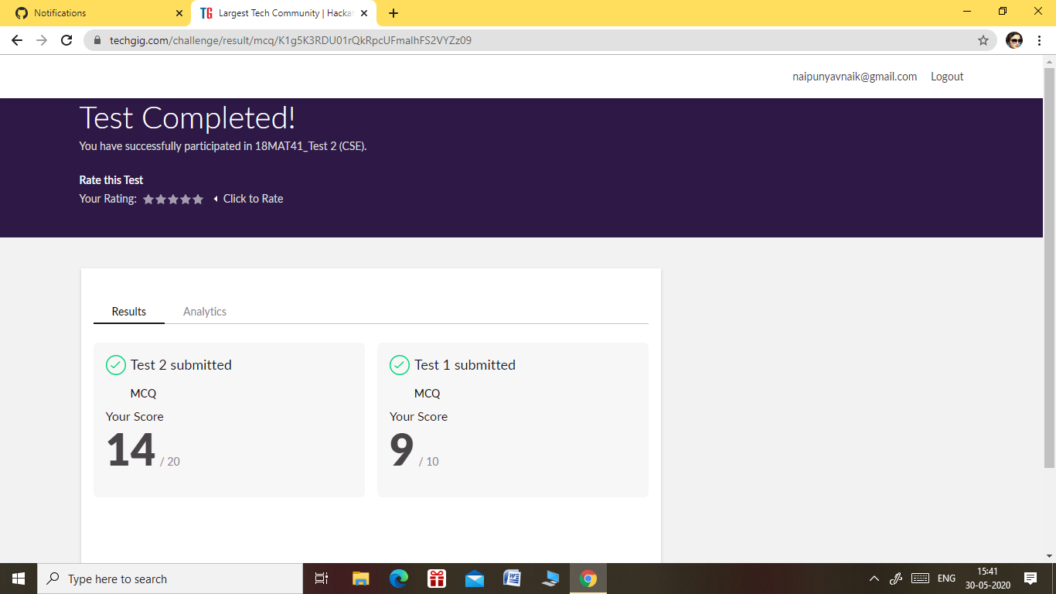

* SUBJECT: - COMPLEX ANALYSIS, PROBABILITY AND STATISTICAL METHODS.
* SYLLABUS:- MODULE 3
* THE 2ND I.A TEST COMPRISED OF TWO TESTS, TEST 1&TEST 2.
* NO. OF QUESTIONS(TEST 1):-10
* NO. OF QUESTIONS(TEST 2):-10
* TEST 1:- EACH QUESTION CARRIED 1 MARK
* TEST 2:- EACH QUESTION CARRIED 2 MARKS.
* START TIME :- 3.00 PM
* END TIME:- 3.40 PM
* DURATION:- 40 MIN

Certification Course Details: (Attach the snapshot and briefly write the report for the same).

CERTIFICATION COURSE NAME:- INTRODUCTION TO CLOUD COMPUTING.

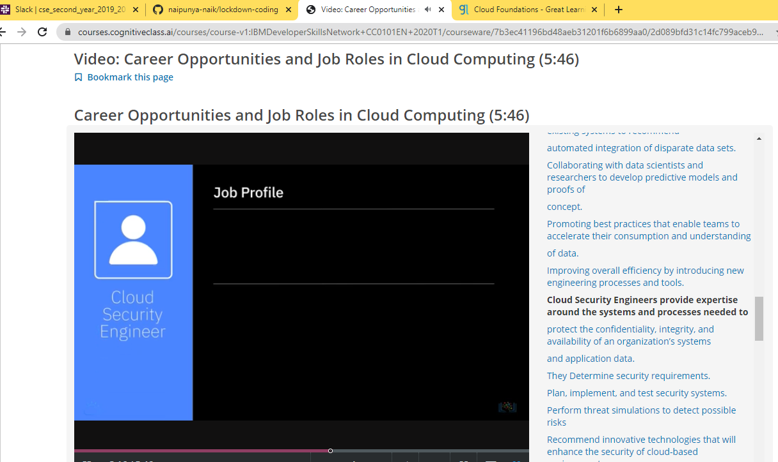

TOPICS LEARNT 30 MAY 2020:-

* MARKET SIZE OF CLOUD SERVICES INDUSTRY.
* CLOUD SECURITY RESPONSIBILITIES.
* CLOUD BUSINESSES ALL AROUND THE WORLD.
* JOB ROLES OF CLOUD DOMAIN.
* LEARNT ABOUT CLOUD BASED SAP APPLICATIONS.

Coding Challenges Details: (Attach the snapshot and briefly write the report for the same)

PROBLEM STATEMENT: - [Write a C Program to count Uppercase, Lowercase, special character and numeric values for a given String](https://github.com/orgs/alvas-education-foundation/teams/2nd-year/discussions/88).

**Input:** Read a String (combination of character, numeric, special character) from keyboard.  
**Ex: #HaaGs01fOr@haaks07**  
 **Output:**   
Upper case letters: 5  
Lower case letters: 8  
Numbers: 4  
Special Characters: 2

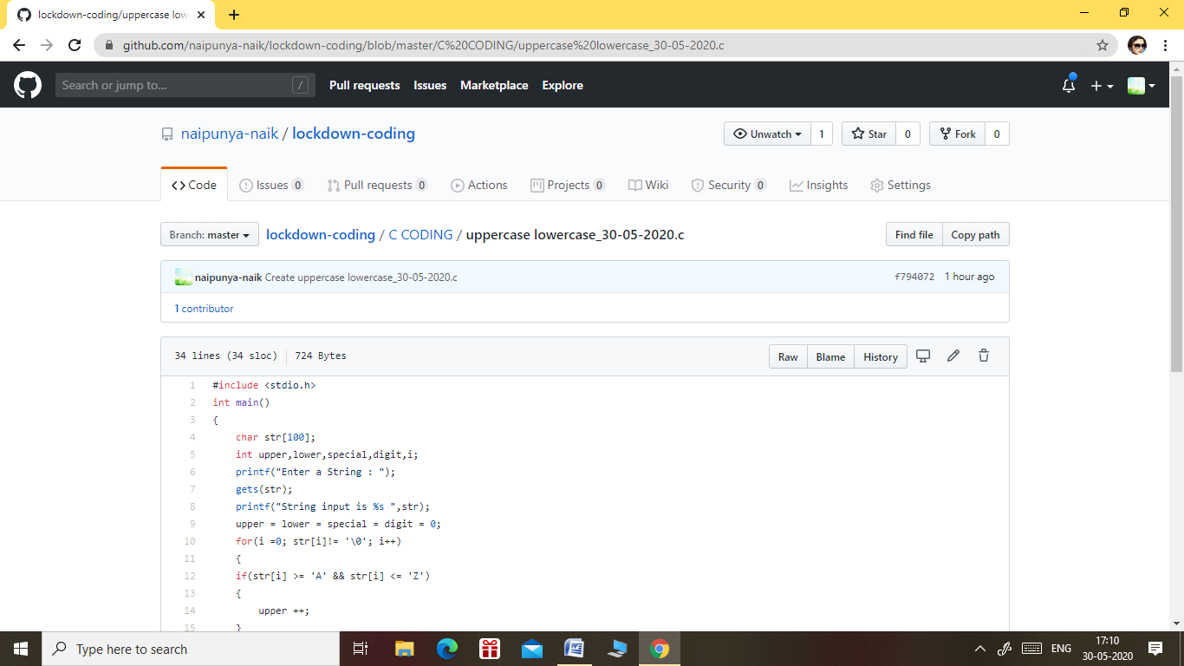

GITHUB REPOSITORY LINK:-

<https://github.com/naipunya-naik/lockdown-coding/blob/master/C%20CODING/uppercase%20lowercase_30-05-2020.c>